- HTTP Version: HTTP/1.1 (browser and server)
- Languages: Check Accept-Language header (likely English variants)
- Your IP: 10.0.0.20
Server IP: 128.119.245.12
- Status code: 200 OK
- Last modified: (check Last-Modified header)
- Bytes returned: (check Content-Length)
- Extra header example: User-Agent
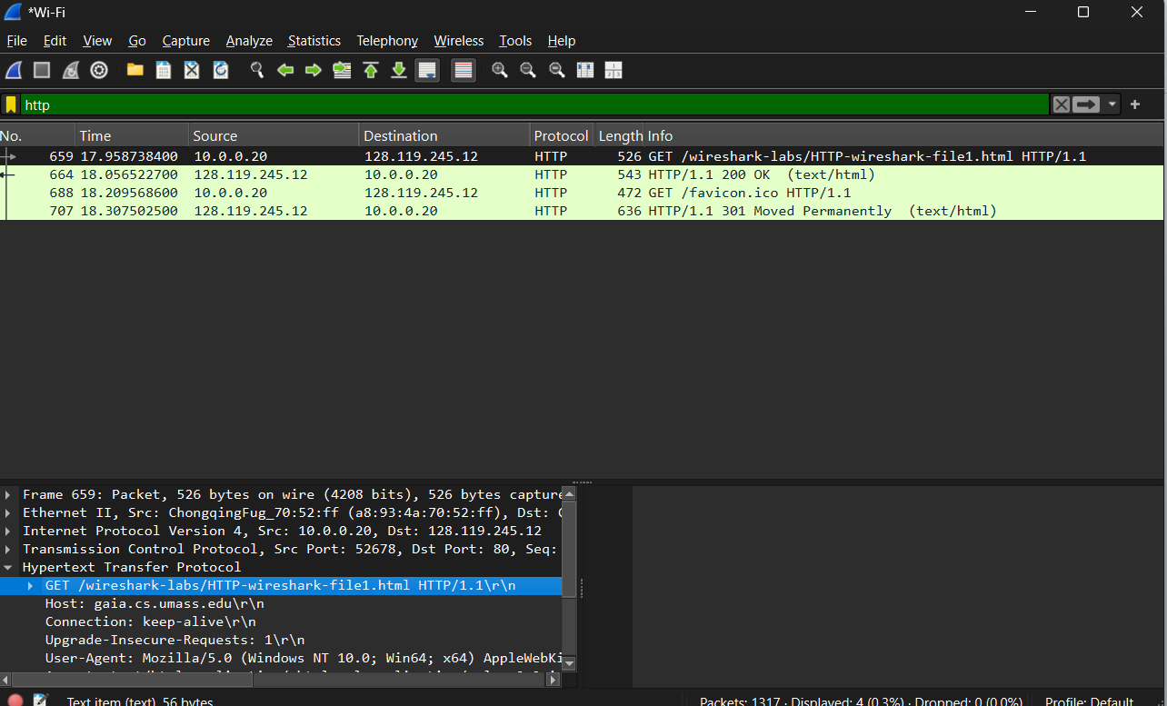

- No, the first HTTP GET does not contain an If-Modified-Since header.
- Yes, the server returned the file contents. The response status code is 200 OK and includes the HTML data.
- Yes, the second HTTP GET contains an If-Modified-Since header. It includes the date and time when the file was last modified.
- The server returned status code 304 Not Modified. The server did not return the file contents; instead, it instructed the browser to use the cached version.

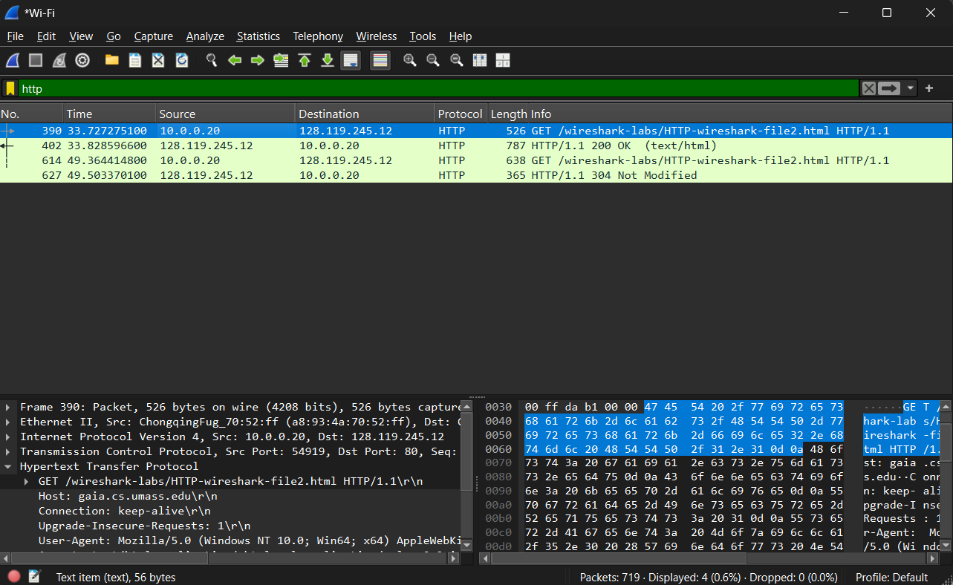

- One HTTP GET request was sent. The GET request is in packet 158.
- The response is in packet 159.
- The status code is 200 OK.
- Four data-containing TCP segments were required to carry the HTTP response.
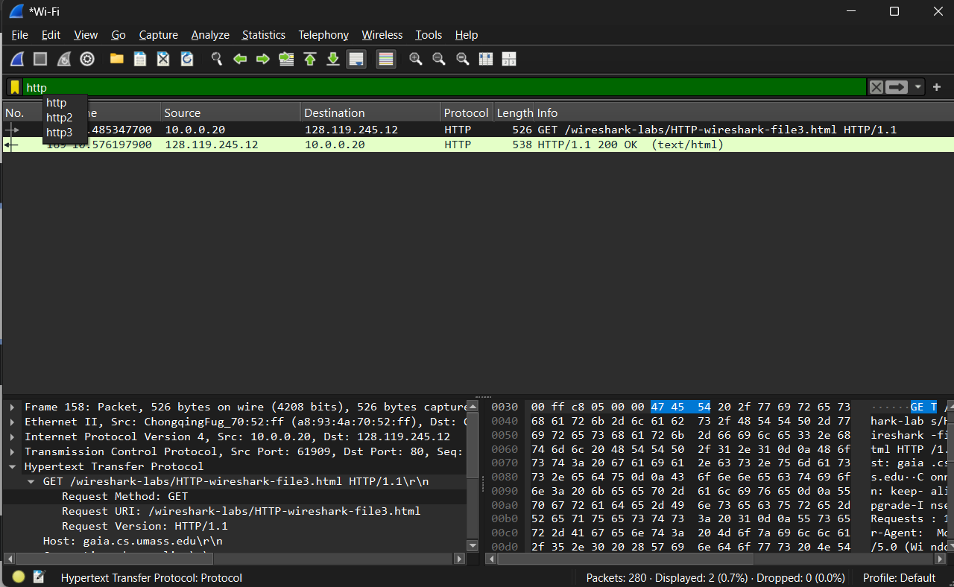

- Three HTTP GET requests were sent. Two were sent to 128.119.245.12 (gaia.cs.umass.edu), and one was sent to a different server with IPv6 address 2601:646:897f:2e50:… .
- The images were downloaded in parallel. This can be determined by observing that the browser sent GET requests to two different servers at nearly the same time, indicating multiple simultaneous TCP connections.
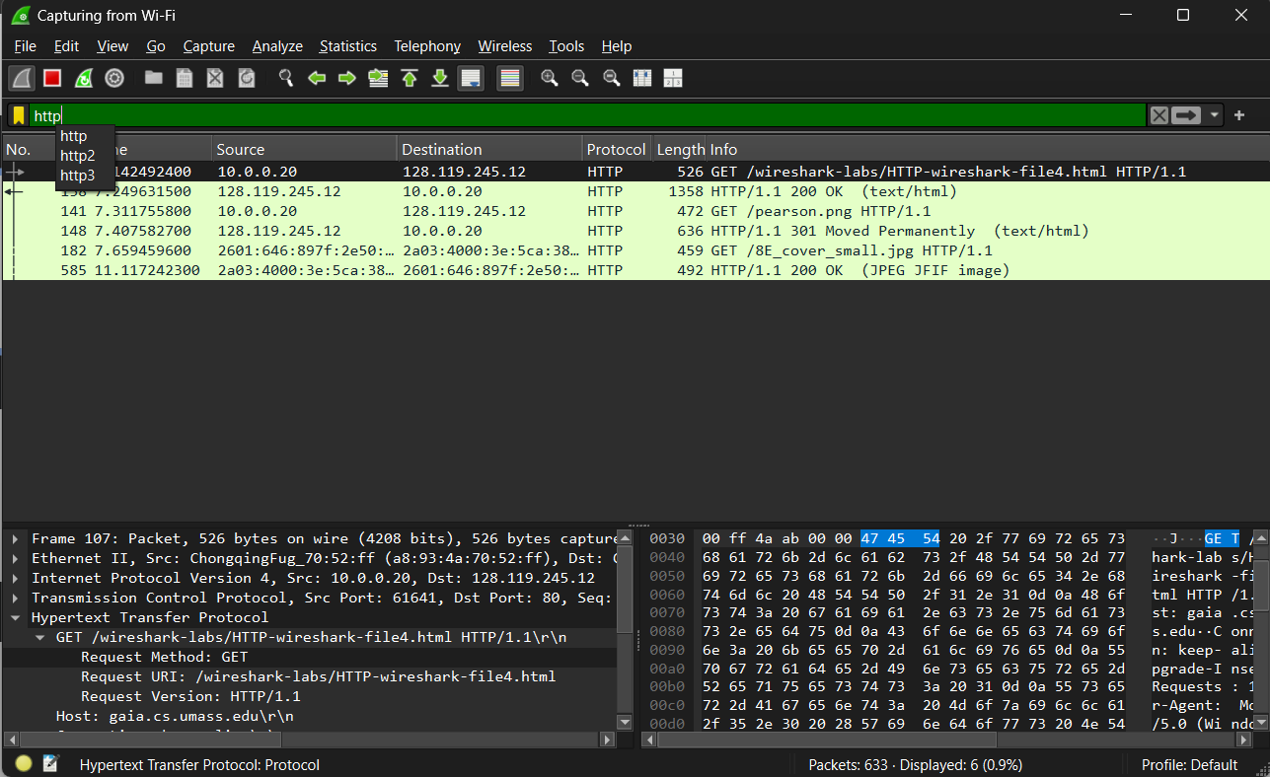

- 401 Unauthorized
- Authorization: Basic header is included in the second GET request
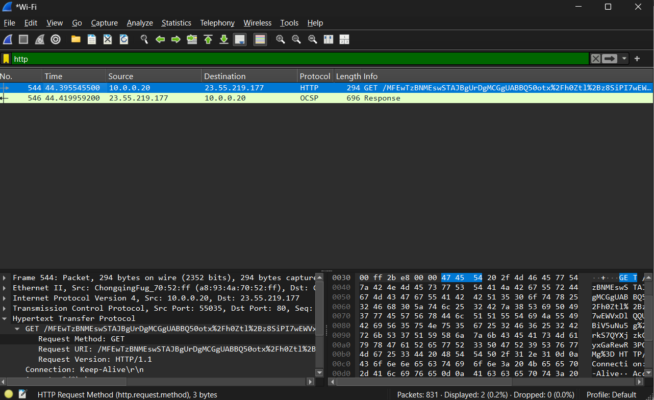
DNS
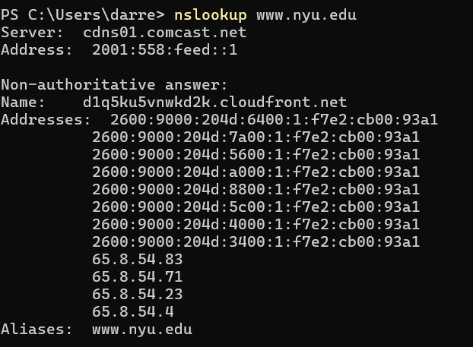
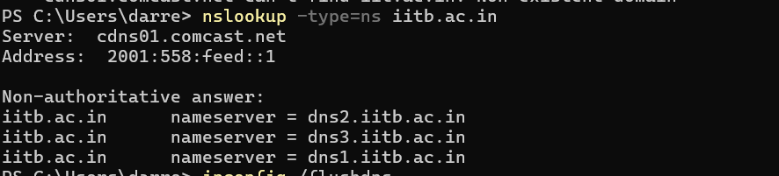
- 103.21.124.133
- 2001:558:feed::1
- The response was non-authoritative
- dns2.iitb.ac.in
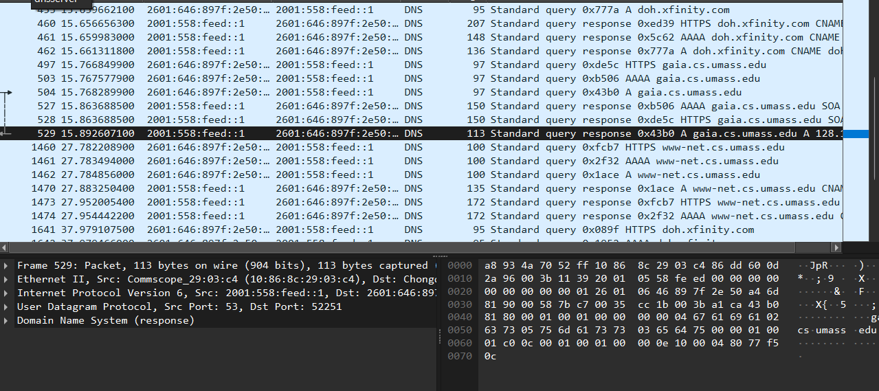
- Packet number: 497 Protocol: UDP
- Packet number: 528 Protocol: UDP
- Destination port of DNS query: 53 Source port of DNS response: 53
- 2001:558:feed::1 (Your Comcast DNS server)
- Questions: 1 Answers: 0
- Questions: 1 Answers: 0** (for the HTTPS record query you showed; the A-record response contains the actual IP answer)
- Questions: 1 Answers: 0** (for the HTTPS record query you showed; the A-record response contains the actual IP answer)The DNS query for gaia.cs.umass.edu occurs only once before the initial HTTP GET request. When the image object is requested, no additional DNS query is sent because the hostname-to-IP mapping is cached by the host. DNS caching stores the resolved IP address for its TTL, allowing subsequent HTTP requests to reuse the cached address without performing another DNS lookup.
- DNS query destination port: 53 DNS response source port: 53
- 2001:558:feed::1
- Type: HTTPS Answers in the query? No (queries have 0 answers)
- Questions: 1 Answers: 0 (it’s an SOA/no-answer style response for HTTPS)
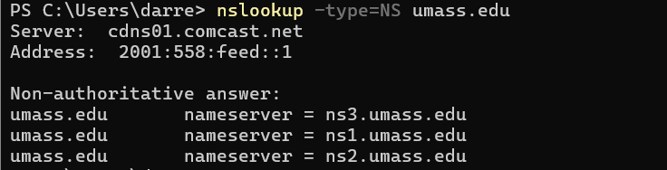
- 2001:558:feed::1
- The DNS query contains 1 question and 0 answers.
- The DNS response contains 3 answers. The answers contain the authoritative name servers for umass.edu (ns1.umass.edu, ns2.umass.edu, and ns3.umass.edu). The response also contains additional resource records that provide the IP addresses of these name servers.

